Assignment

*Topic :* Different Components of Electrical Circuits

1. Resistor:

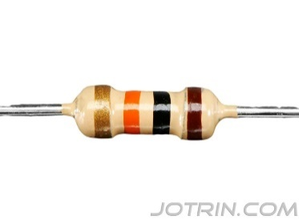

Resistors are tiny electronic components that control and limit the flow of electric current in a circuit by providing a specified amount of resistance measured in ohms (Ω). They are made from materials that resist current flow and come in various types and resistance values. Resistors play a crucial role in countless electronic applications, such as controlling voltage levels, dividing voltages, protecting delicate components from excessive current, and adjusting brightness in LEDs. Color-coded for easy identification, these essential components ensure the proper functioning and safety of electronic devices by dissipating energy as heat.

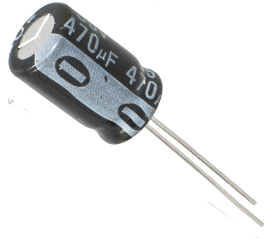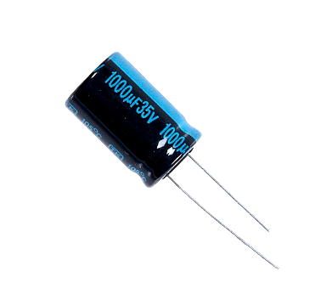 2. Capacitor:

A capacitor is an electronic component that stores electrical energy in an electric field created by two conductive plates separated by an insulator (dielectric). It can quickly release the stored energy, making it useful for smoothing power fluctuations, filtering signals, and temporary memory storage. Capacitors come in various types, such as ceramic, electrolytic, and tantalum, each suited for different applications, measured in farads (F), and are found in nearly all electronic devices, smoothing out power fluctuations, filtering unwanted signals, and even storing temporary memory. They play a critical role by stabilizing voltage and power flow, acting as temporary energy reservoirs that help electronic circuits and systems operate effectively.

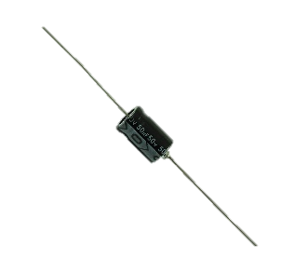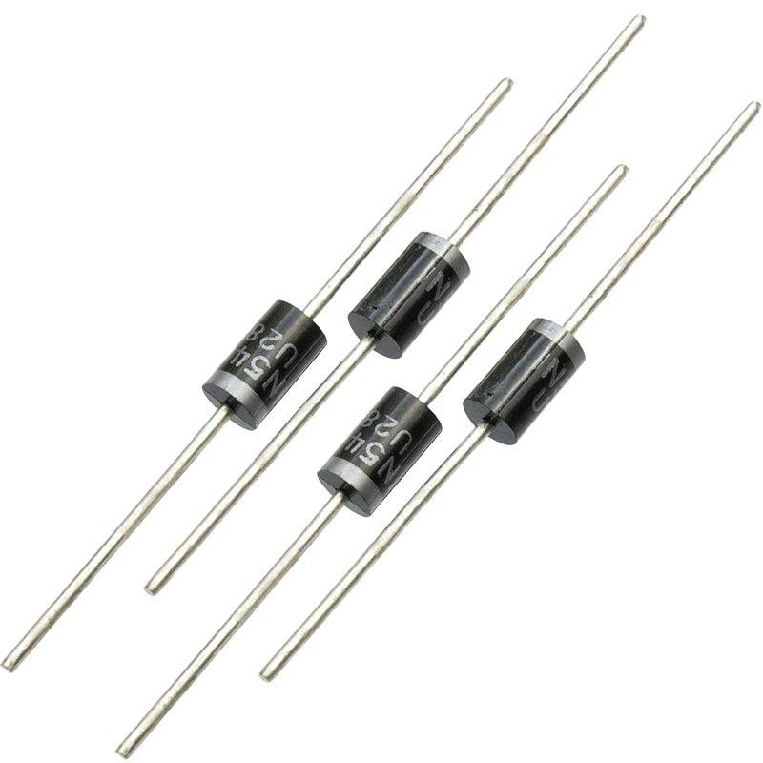 3. Diode :

A diode is an electronic component that allows current to flow in only one direction, acting as a one-way valve for electrical current. It consists of two terminals, an anode and a cathode, and is made from materials that conduct differently based on voltage polarity. Diodes are essential for various applications, including rectification (converting AC to DC), signal demodulation, voltage regulation, and circuit protection. Different types, such as rectifier, Zener, and light-emitting diodes (LEDs), serve specific functions. By controlling the direction of current flow, diodes ensure the proper operation of electronic circuits, protect sensitive components from voltage spikes, and enable diverse functionalities like converting AC to DC and light emission in LEDs.

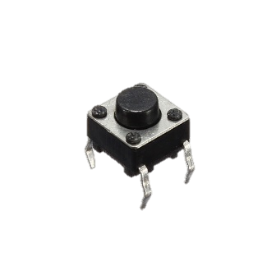 4. Switch :

A switch is a simple yet essential component that controls the flow of electricity in a circuit by physically opening or closing the connection. It allows you to turn devices on/off or change their function by interrupting or completing the circuit. Switches come in various types like toggle, push-button, and electronic, each designed for specific applications. From household light controls to complex industrial machinery, switches provide a vital means of controlling electrical connections, enabling the functionality and safety of countless electrical and electronic systems.

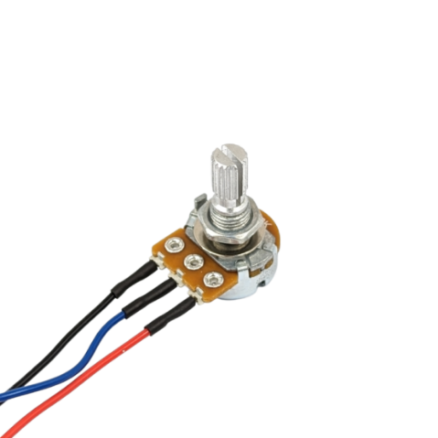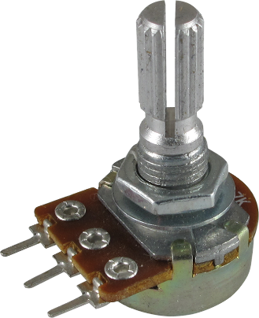 5. Potentiometer :

A potentiometer is an adjustable, three-terminal electronic component that functions as a variable resistor or voltage divider. It consists of a resistive element and an adjustable wiper that allows precise control of resistance, voltage, and current in a circuit by rotating or sliding the wiper position. Potentiometers are widely used for applications such as adjusting audio volume, tuning circuits, controlling light dimmers, and enabling fine-tuning and calibration of electronic devices and systems. Their ability to vary resistance smoothly makes them invaluable for prototyping, testing, and any scenario requiring gradual adjustment of electrical signals or parameters.

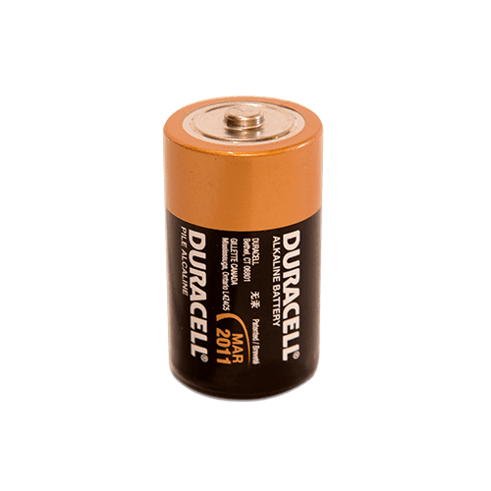 6. Battery :

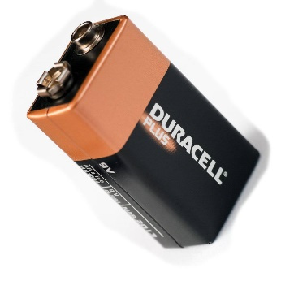

A battery is a portable electrochemical device that converts stored chemical energy into electrical energy to power electronic devices. Unlike constant power supplies, batteries provide direct current (DC) on the go, making them ideal for laptops, smartphones, and other mobile gadgets. They consist of one or more electrochemical cells with positive and negative terminals. Batteries come in various chemistries like alkaline, lithium-ion, and nickel-cadmium, offering different capacities, rechargeability, and environmental impacts. They offer a convenient and reliable way to supply power where a direct electrical connection is unavailable.

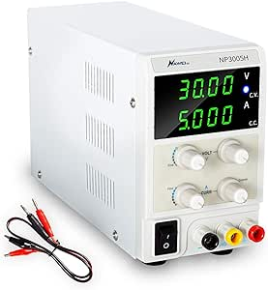 7. Power Supply :

A power supply is an electronic device that converts electrical energy from a source into the appropriate voltage, current, and frequency required by a circuit or electronic device. It acts as an "energy translator," transforming readily available alternating current (AC) into stable direct current (DC) at the required voltage. Power supplies come in various types, including AC-DC converters, DC-DC converters, and uninterruptible power supplies (UPS). They ensure stable and consistent power delivery, protect devices from power surges, and enable the operation of various electronic systems, ranging from computers to industrial machinery. Power supplies are crucial components that bridge the gap between power sources and electronic devices.

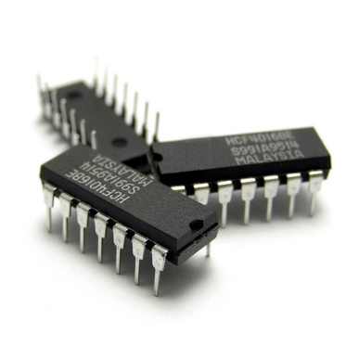 8. Intregated Circuit :

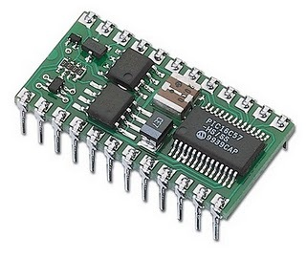

An integrated circuit (IC) is a compact, semiconductor-based device containing interconnected electronic components like transistors, resistors, and capacitors miniaturized onto a single chip. These highly integrated circuits come in various types, including microcontrollers, microprocessors, and memory chips, and perform specific functions such as amplification, signal processing, computation, and data storage. ICs offer high performance, reliability, and miniaturization, enabling the development of complex electronic devices and systems. They are fundamental building blocks of modern electronics, powering everything from smartphones and computers to calculators and automated machinery.

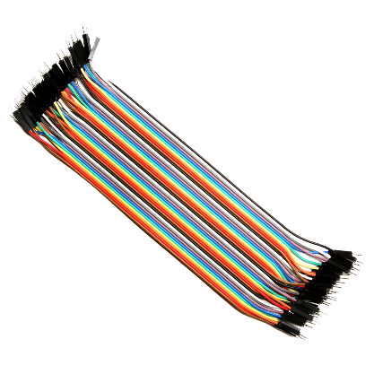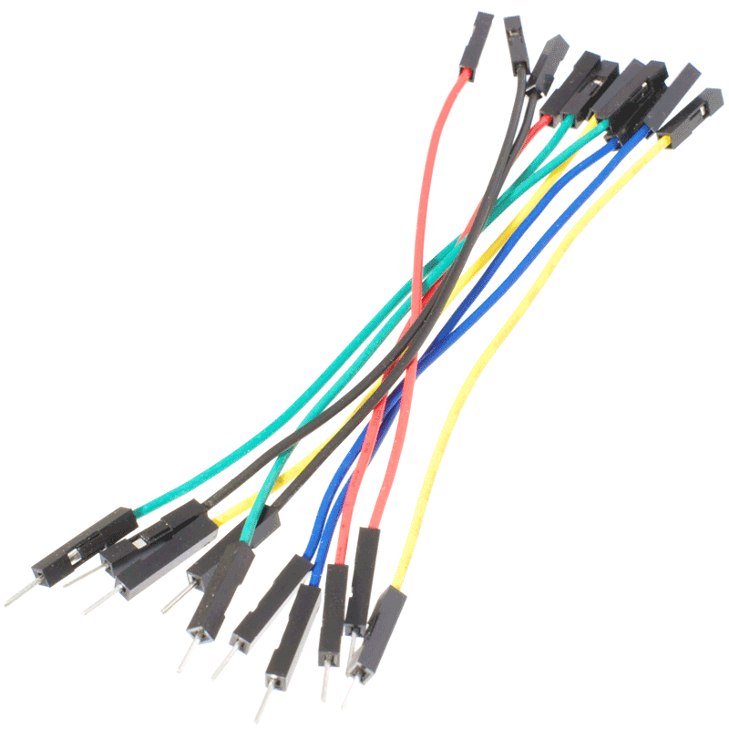9. Jumper Wire :

Jumper wires are short electrical wires with pins at each end, used for establishing connections between components on a breadboard or prototyping platforms. Available in different lengths and colors, these wires simplify circuit organization and identification. They are crucial for prototyping and testing electronic circuits, enabling easy adjustments without soldering. Jumper wires provide a flexible and reusable solution for making temporary connections, streamlining the development and troubleshooting of electronic projects. Essentially pre-cut wires with exposed ends, they can be easily inserted into breadboards to build and modify circuits, bridging gaps between connection points with their flexibility.

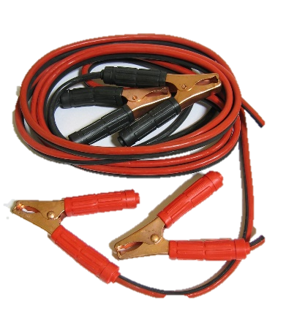10. Alligator Clips :

Alligator clips are versatile electrical connectors with spring-loaded jaws resembling alligator mouths. They are commonly used to temporarily connect wires and components in a circuit without the need for soldering. These clips provide a quick and secure way to establish connections, making them ideal for prototyping, testing, and troubleshooting in laboratories, workshops, and educational settings. Alligator clips feature a spring-loaded metal clamp that opens and closes, allowing easy attachment to bare wires or the leads of electronic components. Unlike jumper wires that are ideal for breadboards, alligator clips can grip onto various wire gauges and component shapes, making them a valuable asset in electronics toolboxes.